Week: 12
Worksheet Experiment:11
“To determine bleeding time by Duke’s method and clotting time by Drop’s method”
Lab Performance (10 Marks):
Total Marks (20 Marks):
Part A: Bleeding Time by Duke’s Method
1) Observations (6 marks):
For Person 1:
Time Duration | Bleeding
10 Seconds | Fresh blood drop visible
40 Seconds | Blood drop visible
60 Seconds | Faint blood dot visible
80 Seconds | Very faint dot visible
100 Seconds | No blood visible
140 Seconds | No blood visible
160 Seconds | No blood visible

2) Picture of Filter Paper (1 mark):
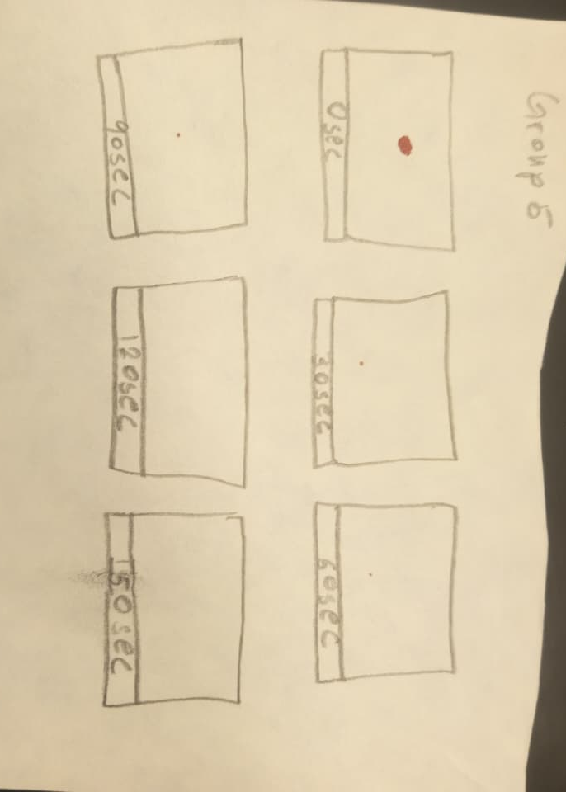
3) Result (3 Marks):
The recorded Bleeding Time was 4 × 30 = 120 seconds.
This value indicates the effectiveness of Primary Hemostasis, which is the body’s initial response to stop bleeding from small vessel injuries. When a blood vessel is damaged, platelets rapidly adhere to the site and aggregate, forming a temporary platelet plug that helps prevent further blood loss.
Part B: Clotting Time by Drop’s Method
4) Observations (6 marks):
- For Person 1:
  - For Person 1:
After pricking the fingertip with a sterile lancet, a small drop of blood appeared, and the stopwatch was started immediately. At 30-second intervals, a clean toothpick was gently touched to the edge of the blood drop to check for fibrin thread formation. Initially, no threads were observed; however, as time passed, thin fibrin strands began to appear between the toothpick and the blood drop. The first appearance of a firm fibrin thread was noted at 340 seconds, which was recorded as the clotting time.
5) Picture of slide with fibrin (1 mark):
We forgot to take the picture
6) Result (3 Marks):
The clotting time determined using Duke’s method was 340 seconds (5 minutes and 40 seconds).
At the site of the prick, platelets adhered and aggregated to help stop the bleeding. These platelets released clot-promoting substances that initiated the clotting process. Subsequently, fibrin threads were observed forming, which reinforced and stabilized the clot.
The measured clotting time falls within the normal range, indicating that the blood’s coagulation mechanism is functioning properly.

7) Error/Problems:
N/A

